Publication template for NDC2017 Conference in Lodz, Poland

Name SURNAME1*, Name SURNAME2, Name SURNAME3

1* affiliation, corresponding author’s email, 2 affiliation, 3 affiliation,

# Abstract

This paper covers formatting guidelines for NDC 2017 Proceedings. Please use the overall style and formatting presented in this document.

# Keywords

Please put your own keywords separated by comma, keyword#1, keyword#2

# 1. Introduction

This document is to present template for the NDC2017 Proceedings as the conference records. The easiest way to follow the proposed style is to download this document and replace it with your own content.

This document is based on the Lodz University of Technology (Poland) university’s press template; hence some of the text may be presented as a look-reference in Polish.

# 2. Text editing

Text should be written using existing predefined styles. “NDC:Text” style should be used to format the content of the article. The template provided to authors for their work has all the form options set up, such as word division or language.

Please do not add headers nor footers. They will be imposed during the composition process. If they will appear in the text of the article, they will be removed.

The “NDC:Text” style has the appropriate settings for paragraphs - indents and spacing. Please do not insert blank lines. During the composition of the text they will be deleted. An example of correct formatting of the article's content is the Introduction Chapter. It is built of several paragraphs without any additional formatting changes.

## 2.1. Numbering – please do not use automatic option

**Please do not use it!** The final composition of the text is to combine all the articles into one Word DOC file. If submitted articles will contain automatic formatting of headings / chapters, pages or lists, it will be sent back for correction.

## 2.2. Footnotes

The footnotes[1] should be unique on each page, in other words, each page should have footnotes 1, 2, 3, etc. Use the Word function to insert text: **Insert -> Footnote**.[2]

## 2.3. Pagination – page splitting

The text should be typed in a continuous style, paragraph after paragraph. Text composition always slightly modifies the text layout on the page. However, it is possible to use the page splitter symbol to visually improve text layout, especially in case of drawing.

## 2.4. Bulleting and numbering

When writing text, it is possible to use numbers and references. To format the numbered list, use the “NDC:NumberedList” format. Below is an example:

1. element number 1,
2. element number 2, its content is very long, so it is possible to see how the text is broken by Microsoft Word
   1. element number a

For bulleting, there is also a separate style “NDC:BulletedList”   
An example of its use is shown below:

* reference number 1
* link number 2, its content is very long, therefore it is possible to check how the text is broken by Microsoft Word
* reference number 3

# 3. Figures

Illustrations should be inserted into the document using the styles of “NDC:Figure” and “NDC:Legend”. The example is shown below:

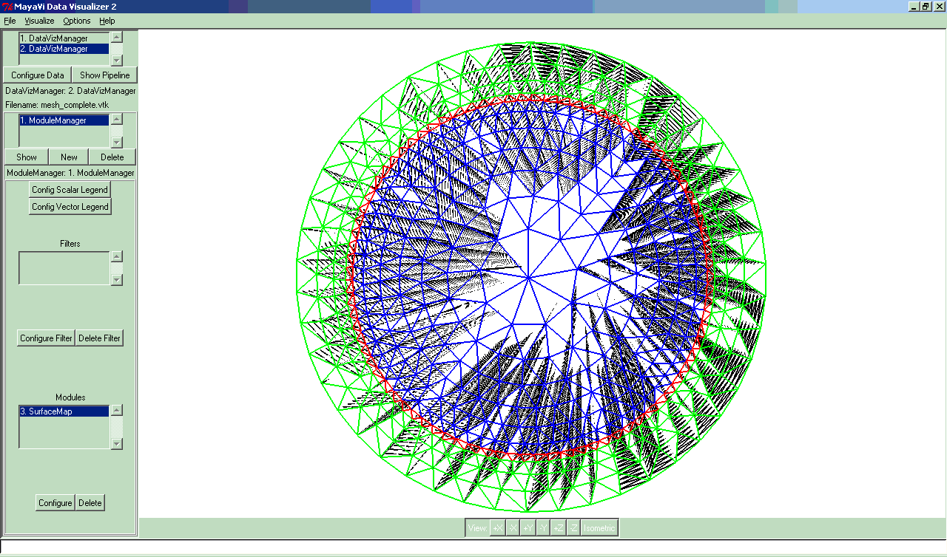

Figure 1. Figure caption

Please use “NDC:Legend” style to format the legend, with the symbol ("Figure 1.") in bold. The minimum and preferred resolution should be at 300DPI.

Please remember to manually number the illustrations, as mentioned in 1.1. Also remember to refer to each figure and table in the text (Figure 1, Table 1).

# 4. Tables

Please tables in a way similar to figures. The legend of the table is formatted with “NDC:Legend” style. For the text in tables use “NDC:TableText” style. It contains visually selected top and bottom spacing, which increases the readability of the table.

|  |  |  |  |
| --- | --- | --- | --- |
| Cell 1 |  |  |  |
|  | Cell 2 |  |  |
|  |  | Cell 3 |  |

Table 1. Table caption

Numbering of tables should be done manually.

# 5. Equations

In order to edit the equations should be used the built-in Microsoft Equation Editor. The format of the equation is designed to regulate the shape and position of the equation number.

 (5.1)

Equations should be numbered manually. The format should include the number of the section (here: 5. Equations), and the next number of the equation within a section.

You refer to the equation in the same format. The equation (5.1) assigns a vector field ∇*f* to the scalar field represented by *f*.

Symbols like gradient should be inserted using the option Insert -> Symbol.

# 6. Conclusion

Authors thank LUT for sharing this template.

# 7. References

The last element of the article should be the literature which was used in the text. Use the style “NDC:References”:

1. Wajman R, Banasiak R, Mazurkiewicz L, Dyakowski D i Sankowski D: *Spatial imaging with 3D capacitance measurements*, Meas. Sci. Technol. 17 No 8, 2006, pp: 2113-2118
2. Soleimani M: *Three-dimensional electrical capacitance tomography imaging*, Insight, Non-Destructive Testing and Condition Monitoring, Vol. 48, No. 10, 2006, pp: 613-617
3. Piegat A: *Modelowanie i sterowanie rozmyte*, Akademicka Oficyna Wydawnicza EXIT, 2001

Please note that items [1] and [2] refer to articles while [3] is a book. References to individual literary entries in the text of the article are made by manual numbering, eg [2].

1. Footnote text
2. Long footnote revealing style – use Times New Roman font, full page aligning, and font size smaller by 1 point than normal text.